Riding the Train to New York (Chapter 8)

I was quite lucky when I got to the station, because I only had to wait about 10 minutes for a train. While I waited, I got some snow in my hand and washed my face a bit. (53)
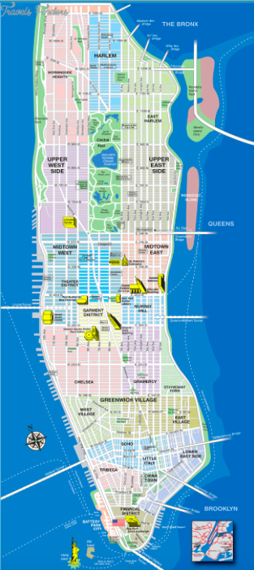
Drawing conclusions Please complete this sentence with an arguable statement:

Based on his behavior and mindset in Chapters 8 and 9, Holden is

The Wicker Bar
Times Square
Edmont Hotel
Penn Station
Ernie’s Bar
Greenwich Village
71st Street/ 5th Avenue
Upper East Side
Central Park
The Carousel
The Lagoon
Museum of Natural History
Statue of Liberty
The first thing I did when I got off at Penn Station, I went into this phone booth. I felt like giving somebody a buzz. (59)

