- Today, you will look more carefully at one of Holden’s experiences and interactions in New York City. Please choose one of the following scenes and sign up to rewrite this scene in a script or screenplay format. You should work with a partner on this assignment.

Chapter 8 Holden and Ernest Morrow’s Mom

Chapter 9 Holden and the cab driver

Chapter 9 Holden and Faith Cavendish

Chapter 10 Holden and the three girls

Chapter 11 Holden and Jane (Flashback)

Chapter 12 Holden and Horwitz

Chapter 12 Holden and Lillian Simmons

Chapter 13 Holden and Sunny

Chapter 14 Holden and Maurice

Chapter 15 Holden and Sally

Chapter 15 Holden and the Nuns

Chapter 15 Holden and Dick Slagle (Flashback)

Chapter 16 Holden and Phoebe’s classmate

Chapter ? Choose an important scene from the text

- Write an “Adapted Screenplay” in which you review the text and script Holden’s interactions, his actions, and his inner thoughts in one particular scene. Please see the reverse side of this handout for a model of how a screenplay should be formatted. Your screenplay / script does not need to follow the text word for word, but it should not change the content, message, and Holden’s word choice significantly. Your script should be 3-6 pages total and capture all or part of a scene. If you find your scene is shorter than 3 pages, continue into the next scene, incorporate a flashback, or add more physical action or description.

- At the end of your scene, each partner should type a well-developed one-paragraph reflection about why they feel this scene is important.

- Please submit your screenplay / script on my website.

- Be prepared to read your script aloud.

Due Date: __________________________

Assignment Value:
20 points for script, 10 points for reflection paragraph.

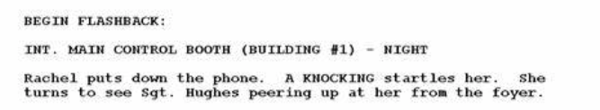
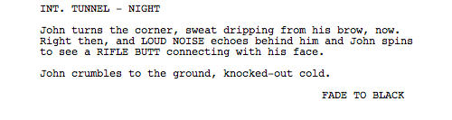
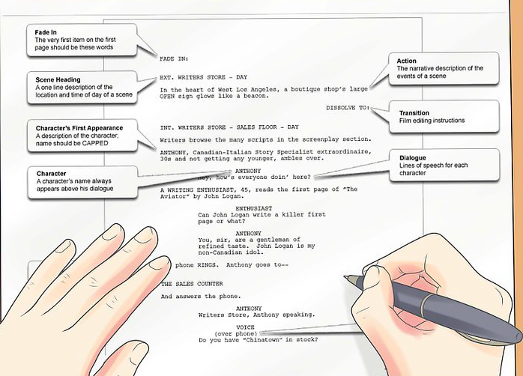
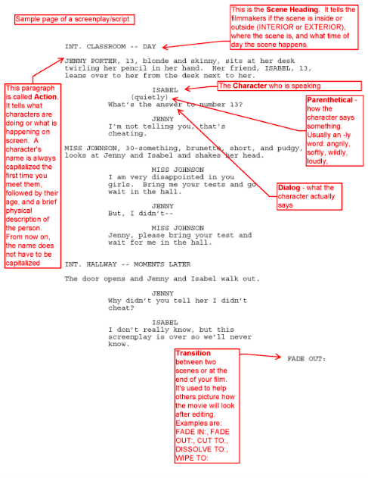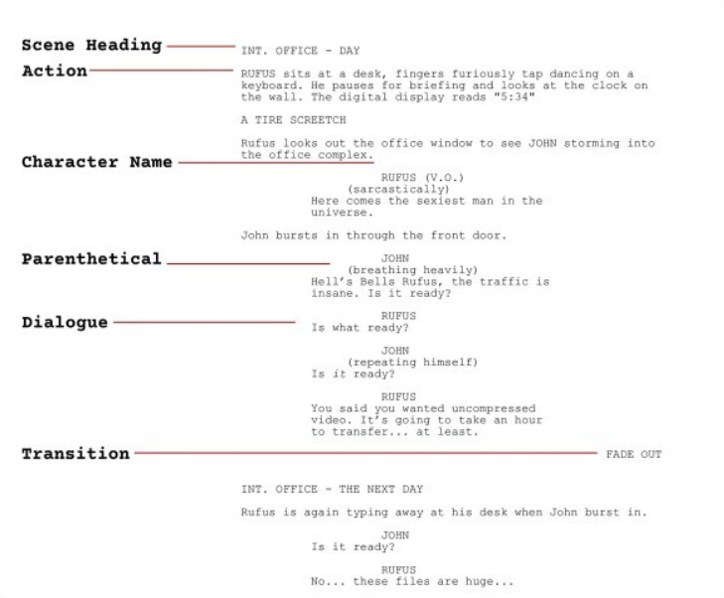
To end a scene, use
“FADE TO BLACK”
Use V.O. (voice over) to indicate inner thoughts.
How to indicate a flashback:

